**SQL Assignment Query**

🡺 **QUERY1:**

select playerName as Batsmens, totalRuns as RunsScored from player

order by totalRuns Desc limit 5;

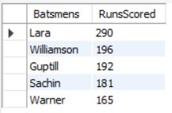

🡺 **QUERY2:**

select playerName as Bowlers, totalWickets as WicketsTaken from player

order by totalWickets Desc limit 5;

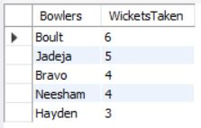

🡺 **QUERY3:**

select teams.country as Country, avg(teamstats.score) as AverageScore

from teams

inner join teamstats on teams.team_id=teamstats.team_id

group by teamstats.team_id;

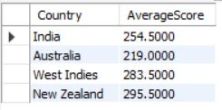

🡺 **QUERY4:**

update player set totalRuns=totalRuns+10

where team_id=(select team_id from teamstats group by team_id order by avg(score) limit 1);

🡺 **QUERY5:**

DELIMITER $$

DROP PROCEDURE IF EXISTS HighestScore$$

CREATE PROCEDURE HighestScore(variable varchar(30), out runs int)

BEGIN

SELECT max(score) into runs from teamstats group by team_id having team_id=(select team_id from teams where country=variable);

END$$

DELIMITER ;

CALL HighestScore('New Zealand',@runs);

SELECT @runs as HighestScore;

